GUI Enhancements for PGSuper II

Introduction
This document provides a description of the changes to be made in the Graphical User Interface (GUI) for the upgrade from PGSuper 1.5 to version 2.0. The requirements for individual features are given in the companion document “Requirements for PGSuper Version II”.

Note that development for PGSuper II is to be broken into three releases (phases). The current version of this document is intended for the support of Phase I development. However, portions of the UI that are affected in subsequent phases may be shown in order to facilitate later development.

Note that only the parts of the UI that will be changed are shown in this document. You should have a running copy of PGSuper v1.5 for reference as you read this document. In addition, certain details, such as how new girders will be displayed in the bridge view, and many reporting changes, are left to be designed at implementation time.

Non-Composite Slab and New Girder Types (Phase I)
The main impact of this change is in the bridge editor Superstructure Tab. Note that girders are now selected by type as well as girder library entry. Note that options for multiple spans (phase II) non-uniform girder spacing (phase III) are not shown in this figure.

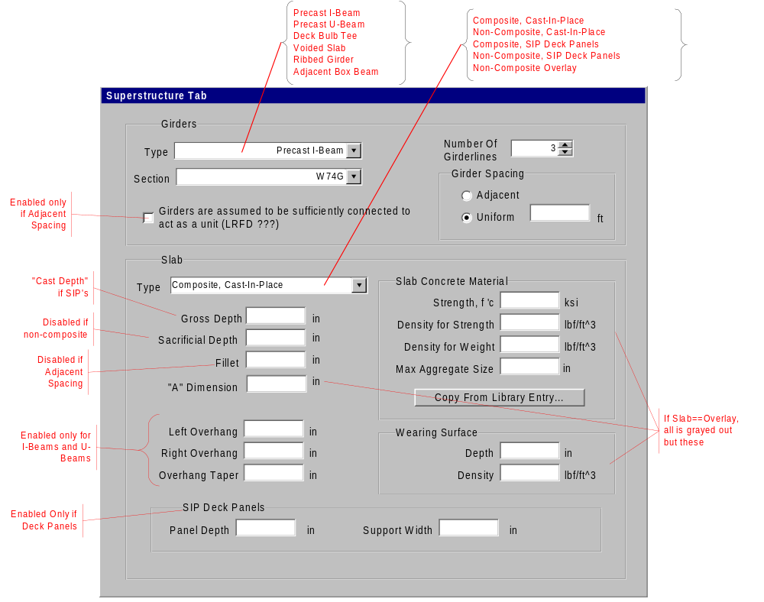

Voided Slab Section (Phase I)
The following will be shown for the Dimensions tab for the voided slab library entry. All other girder library tabs will remain the same.
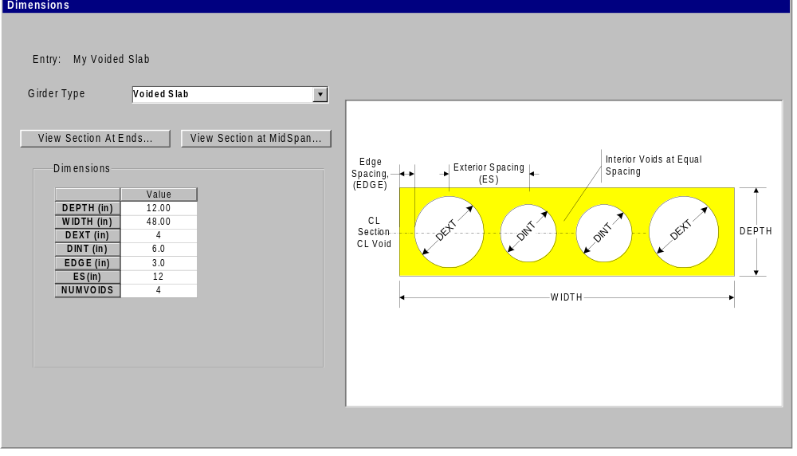

Deck Bulb Tee Section (Phase I)
Dimensions for deck bulb tee sections are defined by the following tab in the girder entry dialog. Note that all dimensions in the schematic are not shown in the figure, but will be implemented in the grid.

Notes:
- The total width of a deck bulb tee girder is dependent on the girder spacing. The minimum girder width is W1MIN and the maximum width is W1MAX.
- W1MIN must be greater than or equal to 2*(T1+W2+W3)
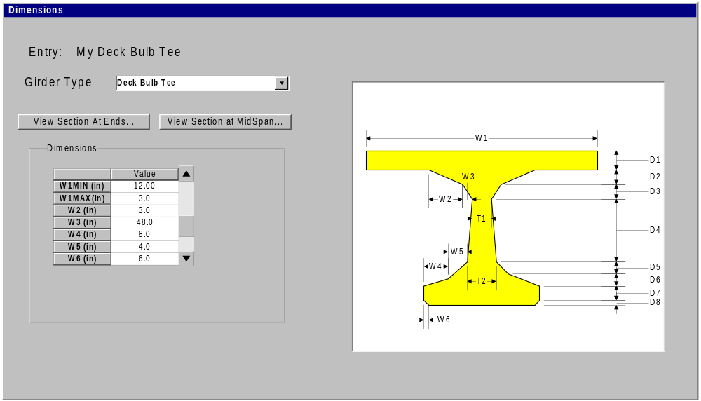

Ribbed Girder Sections (Phase I)
Dimensions for ribbed girder sections are specified in the girder library entry as shown in the figure below. Note that the exterior overhang is defined explicitly and is only used on exterior girders. Hence, the exterior girder need not be symmetrical about the Y axis.
Girder spacing is not specified for this type of girder since they are meant to be adjacent.
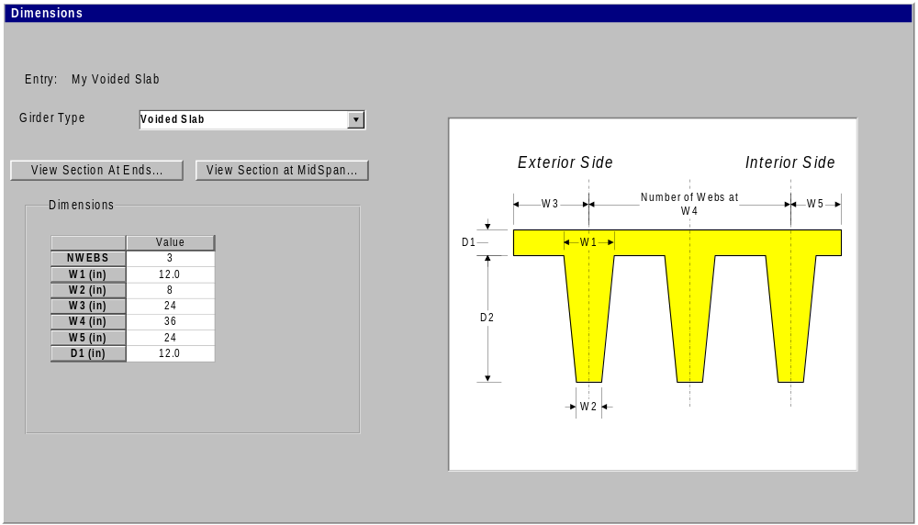

Box Beam Sections (Phase I)
Dimensions for box beam sections are specified in the girder library entry as shown in the figure below. This type of beam can be spaced individually or have adjacent spacing. Note that shear keyways are not modeled.

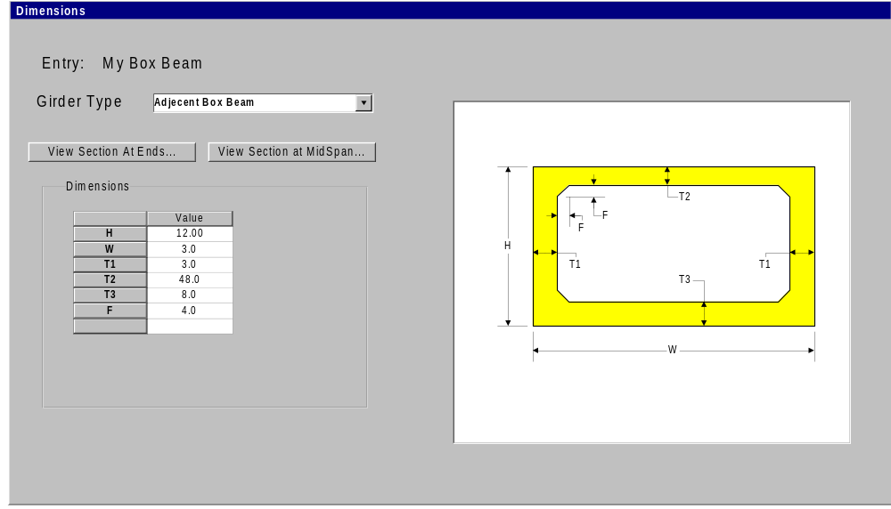

Debonding (Phase I)
The girder editor Casting Yard tab will be modified as shown in the figure below to support debonding of straight strands. The only change to this dialog is the addition of a button to open the Edit Debonding dialog.

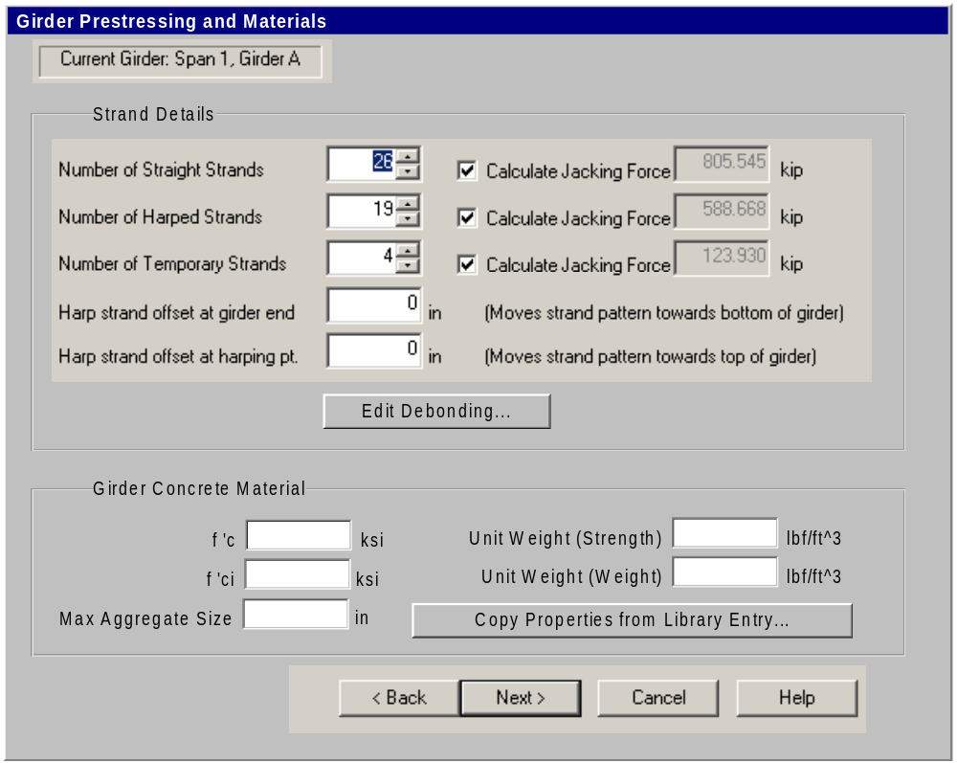

Editing of debond lengths for straight strands is carried out by the following dialog. Note that the fill sequence (order of strands) is identical to that given by the straight strand input for the girder library entry.
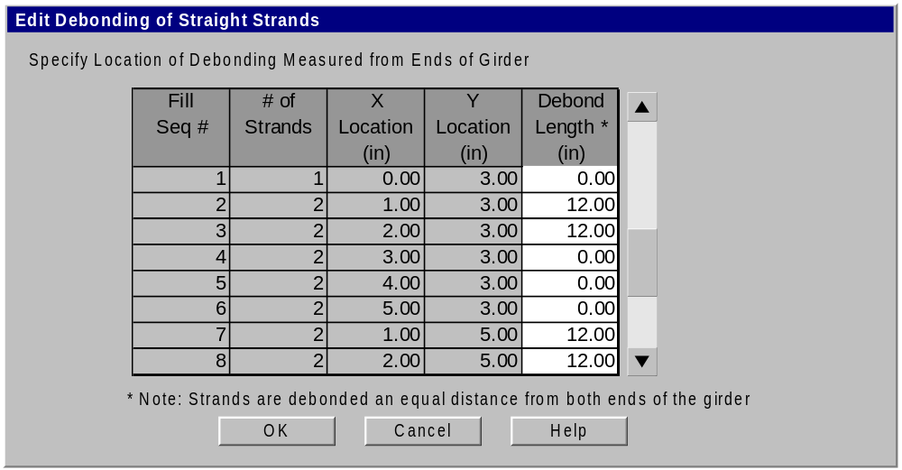

Debonding – Misc. Changes
- Add override values in design criteria library entry for the following:
  - The maximum allowable percentage of total strands that can be debonded. This is normally governed by LRFD (5.11.4.3).
  - The maximum allowable percentage of strands that can be debonded in any given row (a row is defined as that group of strands with equal y-values).
  - The maximum percentage of total strands that can be debonded at any one section
  - The minimum distance between debond sections.
  - Allow debonding of exterior strands (Yes/No)
- Add debond locations to strands report - Change strand numbering in report to match library and debond dialog
- Draw debond locations on girder view (like in PGSplice)
- Modify Design Algorithm so that it designs debonding for girders that do not have harped strands. The user will have to select a designer option (control stresses with harped strands –OR- control stresses with debonded strands). The designer won’t design for a combination of harped and debonded strands.
- Add points of interest at the end of prestress transfer points for debond strands for flexural responses in reports
- If a strand is debonded beyond the mid-point of the girder a Status Item will be generated and the debonding will be ignored by the analysis engine.

Tapering of Slab Overhang (Phase I)
This enhancement was requested by Arizona DOT and reflects a common practice. The overhang taper value is defined as the vertical distance from the bottom of the slab to where the fillet intersects the girder top flange as shown in the following figure. The value is input on the bridge editor – Superstructure tab.

Can this be handled with a simple input parameter (taper to top of girder/taper to bottom of top flange)?

How does this input parameter play out with the various types of girder sections? Does it make sense for U-Beams with CIP slabs? Non-adjacent box beams? Thin-Flange deck bulb tees with composite overlay? Maybe the need for this type of input is a function of the girder/slab type combination.

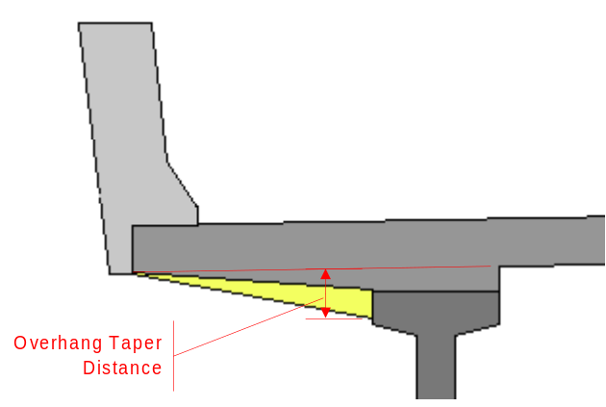

Addition of New Rebar Steel Types
PGSuper allows the specification of a rebar grade for longitudinal and transverse reinforcement. Currently grade 60 is the only type available. A new “Rebar Properties” entry will be added to PGSuper to allow user-defined rebar materials. The library entry editing dialog will look as shown in the following figure:
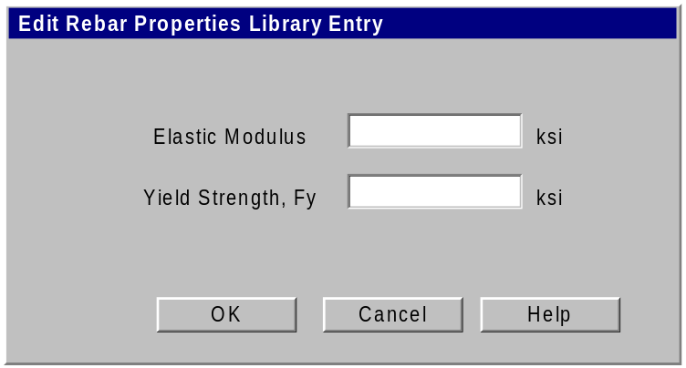

The bridge editor Misc tab must also be modified to allow selection of rebar materials. This section of the dialog will be modified to look as follows:

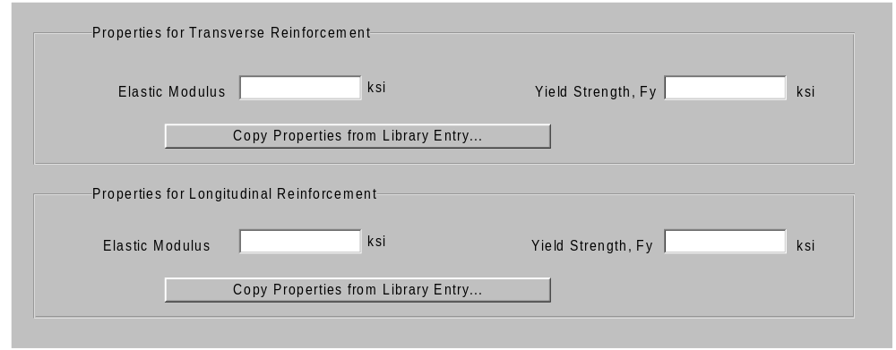

External Applied User Defined Loads
The subsections that follow describe the various facilities available to the user for managing user-defined externally applied loads.
User defined loads consist of a Point or Distributed load applied to a girder line.
Responses due to user-defined dead loads are reported separately (e.g., “User-Defined DC”) in the Product Loads section of the report.

Add/Edit Girder Line Loads
Girder line loads are applied to the bridge model in the Girder View. The girder line displayed in the Girder View sets the context for load editing. To add a load select Loads | Add type Load or right click on the span and select Add type Load from the context menu, where type is Point or Distributed. The appropriate load input dialog is displayed to the user.
Loads can be edited by double clicking on the load graphic, selecting the load and pressing the Enter key, right clicking on the load and selecting Properties from the context menu, or selecting the load and choosing the Edit | Properties menu. This will present the user with the appropriate Load Input Dialog.

Load Input Dialogs
The Load Input Dialogs are used for creating or editing individual loads. The location of a load can be measured with an absolute distance or a fractional distance. The location of a load is measured from the left bearing point of the span to which it is applied.
Loads with a positive magnitude are applied in the direction of gravity or, in the case of moments, counter-clockwise (moment vector out of the screen - positive Z direction).
If the "All Spans" option is selected, the load is applied to all spans.
If the "All Girders" option is selected, the load is applied to all girders.
The user must associate the load with a Load Group (DC, DW, or LL+IM) and a stage of application (Bridge Site 1, 2, or 3 – LL+IM can only be applied to stage 3).

Edit Loads
The following dialog is brought up by selecting “Loads | Edit User-Defined Loads” from the menu. It allows a user to see and edit all user-defined loads applied to the bridge.

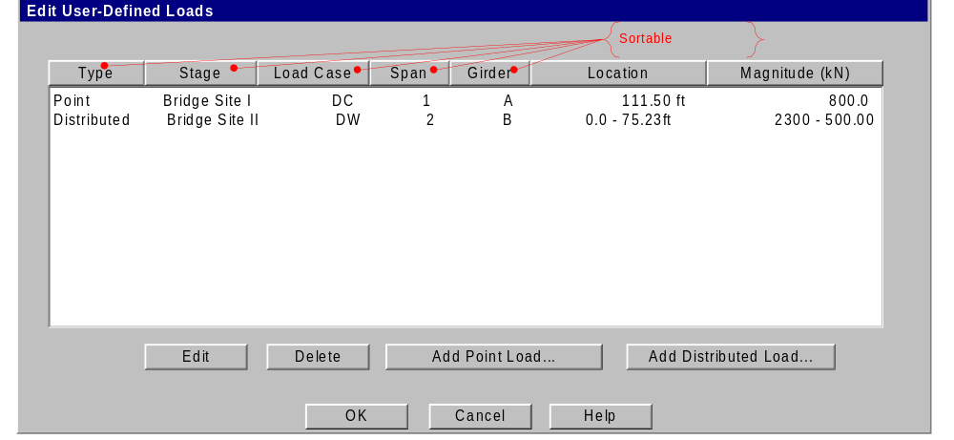

Point Load
The load input dialog for Point Loads is shown in Figure 1. A point load is defined by its location and magnitude. The load is located from the left support and must lie within support boundaries.
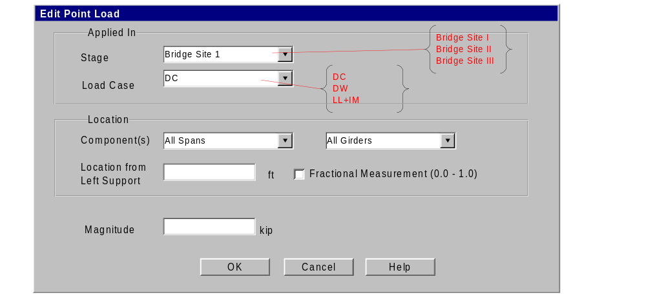
Figure 1 – Edit Point Load

Distributed Load
The load input dialog for Distributed Loads is shown in Figure 2. A Distributed load is defined by its starting and ending location and the intensity of the load at its starting and ending position. The load is located from the left support and must lie within support boundaries. The user can select the Uniform Load option button to enter a Distributed load with a constant intensity.
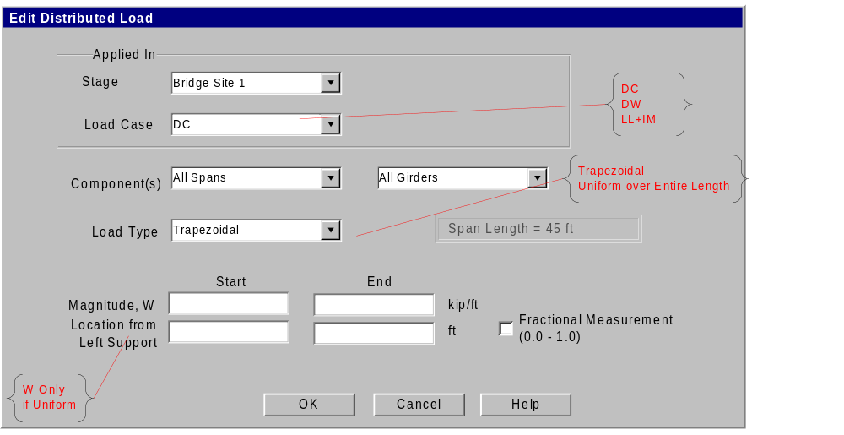
Figure 2 – Edit Distributed Load

Cut/Delete Load
Loads are removed from the model by cutting or deleting them. Cutting a load places a copy of it on the clipboard for subsequent paste operations. Deleting a load removes it from the model.
To cut a load, select the load and choose Edit | Cut, press the right mouse button and choose Cut from the context menu, or press Ctrl+X.
To delete a load, select the load and choose Edit | Delete, press the right mouse button and choose Delete from the context menu, press Ctrl+D, or press the Delete key.

Copy Load
The currently selected load can be copied to either the clipboard for a subsequent paste operation.

Copy to Clipboard
To place a copy of a load onto the clipboard, select the load and choose Edit | Copy, right click on the load and select Copy from the context menu, or press Ctrl+C.

Paste Load
Loads copied or cut to the clipboard can be pasted to any span in the structure. To paste a load, select the target span and choose Edit | Paste, right click on the span and select Paste from the context menu, or press Ctrl+V.

Pasting Semantics
The following describe the behavior of the program when loads are pasted.

Load Defined with Fractional Measure
A load defined with fractional measure easily pastes into any span in the structure. The fractional measure is maintained.

Load Defined with Absolute Measure
One of two things can happen when a load defined with absolute measure is pasted into a span. The load with either fit into the span or it won’t. If the load fits, it is simply added to the span. When a load doesn’t fit, it is still added to the span but an item will be put in the Status Center telling the user the load is off the span and will be ignored.

User Defined Live Load
In addition to assigning a Point or Distributed load to the LL+IM group, a user defined live load can be defined that is applied to the Strength II limit state for ultimate capacities and the standard service limit states.

Live Load Library Entry
User Defined Live Loads will be created and stored in the Live Load Library. User defined live loads consists of a series of axle weight and spacing and an optional uniform load applied simultaneously with the vehicle. The Live Load library entry dialog looks as follows:
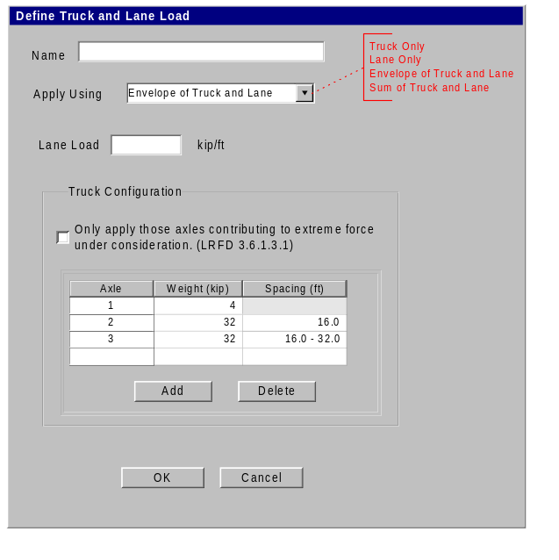
Variable axle trucks can be entered by specifying the axle spacing in “min – max” format. Only one variable spacing can be specified.

Specifying Live Loads for Analysis
Users will specify the live load to be used during analysis by selecting Loading | Live Load. This will display the Live Load dialog. In this dialog the user will select all of the live loads that should be considered. Live loads options consist of the HL93 live load and any of the entries in the live load library.
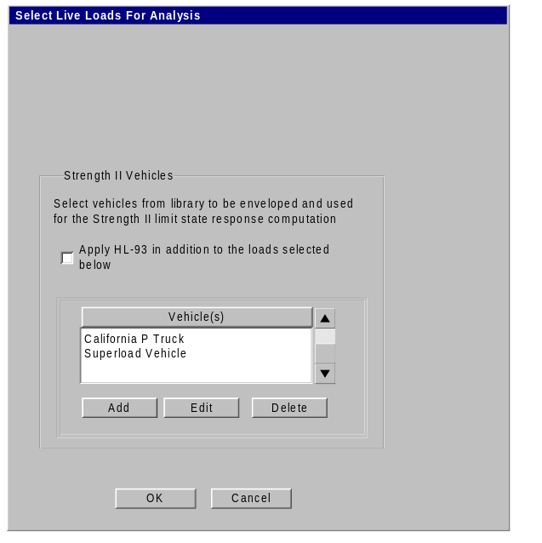

The following dialog will be shown when adding or editing live loads in the vehicle list shown above
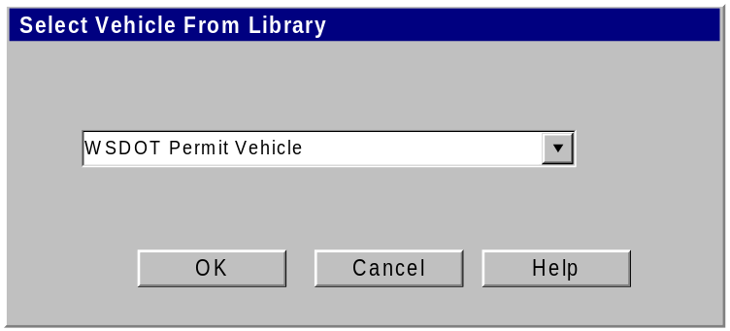

Handling of Input “Errors”
In general, computer programs are intolerant and arrogant. Most programs consider it a “user error” or an “input error” when given input data that they cannot handle. These types of situations are typically rectified by an “error dialog” that rudely gets in your face until the data is changed to the program’s liking (or until you give up and use another program). In fact, these “errors” are typically not due to a mistake made by the user, but by the program’s inability to perform the task at hand.
This is not to say that programs should just quietly accept data that it can’t deal with and blindly calculate and report results based on them. Users must be informed if their input creates physically impossible situations, surpasses known limitations of the program, or just doesn’t make sense. However, we believe that problems with input data should be presented in a more tactful and productive manner. Our solutions to handling input “errors” are given below.

Types of Input Errors
The best way to avoid erroneous input data is simply to make it impossible for users to enter it in the first place. However, this is practically impossible for all but the most trivial of situations. If we are to deal with input errors, we must first know where they come from. For our purposes, we have categorized errors into three categories: 1) Simple Errors, 2) Suspicious Errors, and 3) Complex Errors.
Simple Errors are straightforward and can be detected and prevented directly at the time of input. An example of a simple error is if the user inputs a negative modulus of elasticity, or a negative span length. Another example of a simple error is a syntax error (e.g., entering “abc” as a floating point value). Errors of this type are typically restricted to a single dialog and can be rejected directly in the dialog that they are entered in.

Suspicious Errors represent data that is possible, but not within the normal range expected. An example of this would be an 85 degree skew angle, or an elastic modulus of concrete of 30ksi. These values may be mathematically possible, but are not practical in the real world. In these cases, we will want to inform the user that something may be wrong, but still allow him to continue his work.

Complex Errors stem from problems caused by dependencies on other data. An example of this could occur if a user wants to move his entire bridge by changing the stationing of each pier. During this process, he might place pier 1 down station from pier 3. This is clearly an error, but it is only temporary – he will soon get around to moving the other piers, and he should not be harassed by the program getting in his face about it.

Dealing With Simple Errors
The program should deal with simple errors immediately. It should not be possible to close a dialog if it has “abc” in a field that requires a floating-point number. This first line of defense is to eliminate the possibility of simple input errors. For example, if an input is to be numeric, letter key presses should be ignored. If a number should be positive only, the minus key should not be accepted.

The second line of defense is to provide a hint to the user of erroneous input. If the input control cannot restrict input to only valid data, then it should color the input data. For example, if an input can only be positive values, it is difficult to prevent the user from entering 0.00. If the value in the input control is zero, it will be displayed in red. This will tell the user that if he tries to close the dialog he will be presented with an error message and directed to correct the erroneous input. Then, odds are, the user will correct the problem before the program has to get into his face.

Dealing with Suspicious and Complex Errors – The Status Center
Users should not be forced into dealing with suspicious and complex errors immediately. This means that we need a user interface element that serves to remind users that problem(s) exist, but does not force them to fix them immediately if they don’t want to. This is the purpose of the Status Center.
The Status Center has two main viewable elements in the user interface: A color bar in the Status Bar of the main application window, and a modeless dialog that displays active status items. It is also accessible from the main menu via View|Status Center

Status Center Color Bar
The Status Center Color Bar is located in the far right side of the status bar for the main window and is visible at all times while the application is running. The color bar, as shown in Figure 3, is filled with a color representing the state of the input data for the current project.
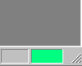
Figure 3 - Status Color Bar
There are three possible states that can be represented by the color bar as shown in the following table
Table 1 - Status Bar Color States
Color | Status Level | Description
 | 1 | All input data is within normal operating parameters. Informational messages may be in the status center and are signified by the starburst mentioned below.
Yellow | 2 | Input data is unusual or suspect, but analyses can be run.
Red | 3 | Input data is out of range for one or more analyses (or plug-ins), but model can be viewed, exported, and processed by some analyses. Analyses with problems cannot be run.
When new messages are logged, the status color bar shall show a starburst until a subsequent command is executed or until the Status Center is visited. For example:
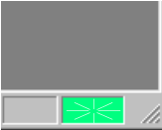
Figure 4 - Status Color Bar Indicating New Message

Color Bar Mouse Interactions
The color bar supports limited mouse interactions as shown in the table below.
Action | Result
Pause mouse-over  or Single Click | Display tooltip showing most recent, highest-level message in status queue, or “Status OK” if green.
Double Click | Bring up Status Center dialog

Status Center Dialog
The Status Center dialog is a modeless dialog that can be access by double clicking on the Status Color Bar or via View|Status Center on the main menu.
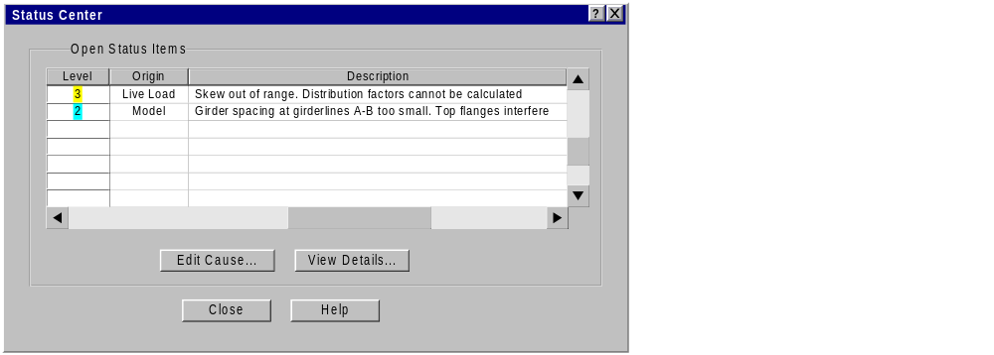
Figure 5 - Status Center Dialog
The Status Center dialog contains a list box of status items. Each status item represents an issue with the current input data. Issues are listed in order of relative importance (as determined by the system).
The fix for some status items will be straightforward enough so that the cause can be edited directly. In this case, the issue can be double-clicked, or selected and then pressing the “Edit Cause” button. This will bring up the editing dialog for the data item with the item highlighted.
The “View Details…” button will bring up a dialog showing the details of the current status item. This dialog contains a text field that can show additional information about how to reconcile the problem in question.
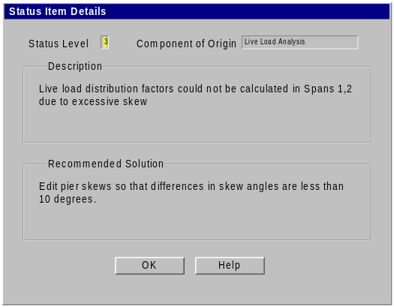
Figure 6 - Status Item Details

Below is a start of the interfaces needed to make the status center work. Some modifications are expected as actual implementation proceeds. It is documented here to keep it from getting it lost.

IStatusCenter
uid = Add(IStatusItem* item)
RemoveByUID(uid)
RemoveByIndex(index)
IStatusItem* GetByUID(uid)
IStatusItem* GetByIndex(index)
long Count()

uid - Status items can be logged from anywhere in the application. UID is a unique identifier for the status item. UID will be set on a status item when it is added to the status center. Don't change this property yourself.

The StatusCenter owns (is responsible for deleting) Status items.

IStatusItem - Abstract base class interface for all status items

IStatusItem
void SetUID(uid)
uid GetUID()
string GetDescription()
callbackID GetCallbackID()
bool IsEqual(IstatusItem* other)

callbackID - Some identifier that is used to bring up an editing interface. Status items (errors) will be identified in the agents but it is the executable that provides the UI. The agent logging the error needs to give the UI some clue as to what UI element it needs to present to the user.

It is most convenient for agents to log status items without keeping track of previously logged items. The status center needs a method of determining if an identical status item has been previously logged. If so, a second item is not logged. The IsEqual method is used to determine the equality of two status items.

IStatusCenterEvents
OnStatusItemAdded(uid)
OnStatusItemRemoved(uid)

Status center events primarily need to be received by the UI Status Bar (so the starburst, color, and tooltip can change) and by the Status Center dialog (so it can keeps its display up to date).

Implementation Thoughts: I’m thinking that the IstatusCenter interface should be implemented on the DocProxy agent. Recall that the DocProxy agent is the glue between the MFC Doc/View architecture and the PGSuper Agent/Broker architecture. The DocProxy agent knows both the Broker and the MFC Cdocument derived class. The implementation of the DocProxy agent could delegate implementation to the Cdocument object. Cdocument has good access to Cview objects, and the Frame windows.

Definition of Multiple Spans and Removal Of Connection Library Entry (Phase II)
The use of a connection library to specify beam end and bearing location data has caused some confusion. Hence explicit values will be now shown in the user interface to provide better feedback. The Connections library entry will be done away with. This change will be done in conjunction with the addition of multi-span capability. The Piers tab in the bridge editor will be replaced by a “Framing Plan” tab as shown in the following figure:

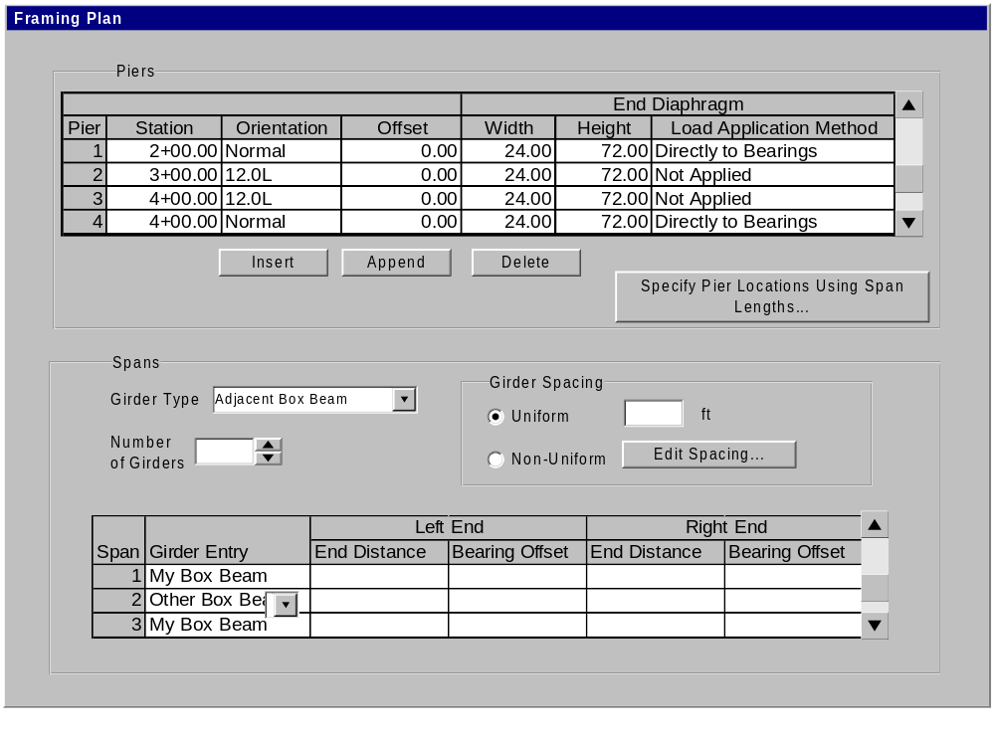Note that the girder types and spacing information will be removed from the Superstructure Tab because beam types and girder spacings are now specified in this tab.

This is a good start but we really shouldn’t focus too much more on this UI element unless it is necessary during implementation of Phase I.

